Game Design Document

Fill up the following document

1. Write the title of your project.

DOODLE JUMP

1. What is the goal of the game?

THE GOAL OF THE GAME IS TO CLIMB AS MANY STAIRS AS IT CAN AND COLLECT POINTS

1. Write a brief story of your game.

:-

ONE DAY TWO FRIENDS WERE PLAYING IN A PARK ON THE STAIRS.SUDDENLY ONE FRIEND TOLD THE OTHER THAT HE KNEW OF A PLACE AS MAGIC STAIRS WHERE THEY HAVE TO CLIMB THE STAIRS AND EARN MONEY/GOLD COINS AND ALSO TOLD HIM ABOUT THE CHALLENGES AND DIFFCULTIES PRESENT THERE.BUT THE OTHER ONE AGREED AND WENT TO PLAY THE GAME .SO HE PLAYED THE GAME AND WON 10000000$.BUT NOW HE WANTS TO SHOW HIS FRIEND THE SAME GAME BY MAKING A GAME.HE MADE THE GAME BUT HIS FRIEND IS NOT ABLE TO PLAY IT AS HE IS FALLING DOWN AGAIN AND AGAIN.PLEASE HELP HIM TO PLAY THE GAME.

1. Which are the playing characters of this game?

* Playing characters are the ones who respond to the user based on the input from the user.
* Cars, monkeys, dinos, wizards, etc., are the playing characters in the game.

|  |  |  |
| --- | --- | --- |
| Number | Character Name | What can this character do? |
| 1 | DOODLE | IT CAN JUMP AND COLLECT COINS |
| 2 |  |  |
| 3 |  |  |
| 4 |  |  |
| 5 |  |  |
| 6 |  |  |
| 7 |  |  |
| 8 |  |  |
| 9 |  |  |

1. Which are the Non-Playing Characters of this game?

* Non-Playing characters are the ones that don't have an action or behavior when the user interacts with the game.
* Hurdles, stones, bananas, coins, etc., are non-playing characters in the game.

|  |  |  |
| --- | --- | --- |
| Number | Character Name | What can this character do? |
| 1 | BARS | WORK AS STAIRS FOR DOODLE TO JUMP |
| 2 | MOVING BARS | AS A CHALLENGE TO DOODLE |
| 3 | BROKEN BARS | TO FOOL THE DOODLE AND MAKE IT FALL DOWN |
| 4 | MONSTERS | TO KILL THE DOODLE |
| 5 | COINS | TO BOOST THE SCORES OF DOODLE |
| 6 | GAME OVER SPRITE | TO DISPLAY THE GAMEOVER |
| 7 |  |  |
| 8 |  |  |

Draw your imagination of this game. What does this game look like?

* Draw the game either on your computer or on paper.
* IT WILL LOOK LIKE A NORMAL SCREEN WHERE THE DOODLE WILL BE JUMPING
* Add images of the game scenes to show each of the playing and non-playing characters at least once.

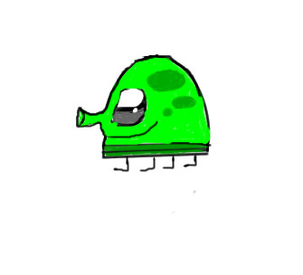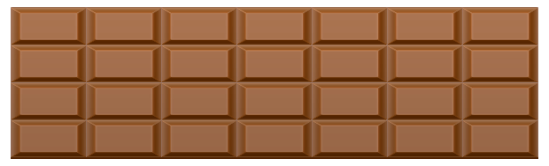

[This Photo](http://physics.stackexchange.com/questions/238202/why-do-chocolate-bars-usually-break-at-the-cleavages) by Unknown Author is licensed under [CC BY-SA](https://creativecommons.org/licenses/by-sa/3.0/)

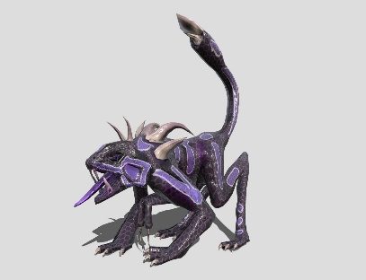

[This Photo](https://sketchfab.com/3d-models/monstro-para-jogos-monster-for-games-2957e37e7f6a40809717f79033d824d3) by Unknown Author is licensed under [CC BY](https://creativecommons.org/licenses/by/3.0/)



[This Photo](https://freepngimg.com/png/66672-coin-transparent-gold-icon-free-photo-png) by Unknown Author is licensed under [CC BY-NC](https://creativecommons.org/licenses/by-nc/3.0/)

How do you plan to make your game engaging?

PC & NON-PC:DOODLE AND OTHER;

STORY:WRITTEN ABOVE;

GOAL:WRITTEN ABOVE;

FEEDBACK:BY GIVING SCORES AND COINS COLLECTED;

ADAPTIVITY:SPEED AND QUANTITY OF MONSTERS INCREASES AS GAME PROCEEDS;

CHANCE vs SKILLS:CHANCE IS THAT DOODLE MAY FALL DOWN,SKILL IS TO SAVE THE DOODLE FROM FALLING DOWN AND SAVING IT FROM MONSTERS;

RULES:CONTROL THE DOODLE:PRESS ARROW KEYS TO MOVE THE DOODLE RIGHT AND LEFT,PRESS SPCE TO MAKE THE DOODLE JUMP;

BALANCE:THERE WILL NOT BE MUCH OBSTACLES AND GAME WILL BE MEDIUM WITH SOME EASY THINGS AND SOME HARD OBSTACLES;